Tooth Anatomy Worksheet

Name: _____________________________ Course: _____________________________

Date: __________________ Period: ________

Color the parts of the pictures as you work through the screen.

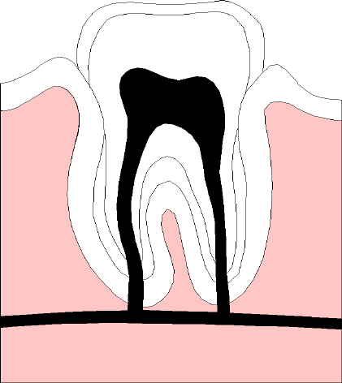

Plaque Detection Experiment Instructions

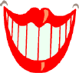
Locate a disposable pre-pasted toothbrush and disclosing tablet for each student. Once you are at a sink/faucet do the following:

- Begin by brushing your teeth following your normal routine. You will probably need to wet and "loosen up" the pre-pasted toothbrush prior to using it.

- After brushing and rinsing your teeth, open a packet containing a disclosing tablet.

- Chew up the tablet; do not swallow the tablet.

- Spit out any excess.

- Examine your teeth. Any areas stained with pink or red are indicators of plaque left behind.
Note: If possible, consult with your partner, and show each other the major areas plaque was missed during the brushing process.

- Brush your teeth until no areas of pinkish/red stained plaque remain.

Once you have finished the experiment, return all items to their proper storage locations, go back to your workstation, and continue with the next screen in the course.

Challenge Lab Sheet

Name: _____________________________ Course: _____________________________

Date: __________________ Period: ________

Directions: Listed below are seven steps to problem-solving. Fill in each step, using complete sentences, to achieve the best results.

Describe the problem:
_____________________________________________________
_____________________________________________________
_____________________________________________________

Describe the desired results:
_____________________________________________________
_____________________________________________________
_____________________________________________________

Research the problem:
_____________________________________________________
_____________________________________________________
_____________________________________________________
_____________________________________________________
_____________________________________________________

Think of three alternative solutions. Give a brief description of each (attach additional sheets if necessary).
_____________________________________________________
_____________________________________________________
_____________________________________________________
_____________________________________________________
_____________________________________________________

Choose the best solution:
_____________________________________________________
_____________________________________________________
_____________________________________________________
_____________________________________________________
_____________________________________________________

Choose the best solution:
_____________________________________________________
_____________________________________________________
_____________________________________________________
_____________________________________________________
_____________________________________________________
_____________________________________________________
_____________________________________________________

Study the results and make improvements:
_____________________________________________________
_____________________________________________________
_____________________________________________________
_____________________________________________________
_____________________________________________________
_____________________________________________________
_____________________________________________________

MATERIALS:
_____________________________________________________
_____________________________________________________
_____________________________________________________
_____________________________________________________
_____________________________________________________
_____________________________________________________

NOTES:
_____________________________________________________
_____________________________________________________
_____________________________________________________
_____________________________________________________
_____________________________________________________
_____________________________________________________
_____________________________________________________
_____________________________________________________
_____________________________________________________
_____________________________________________________
_____________________________________________________
_____________________________________________________
_____________________________________________________
_____________________________________________________
_____________________________________________________

Challenge Research Sheet

Name: _____________________________ Course: _____________________________

Date: __________________ Period: ________

Directions: Listed below are seven steps to problem-solving. Fill in each step, using complete sentences, to achieve the best results.

Describe the topic:
_____________________________________________________
_____________________________________________________
_____________________________________________________

Describe the three main points of your presentation:
_____________________________________________________
_____________________________________________________
_____________________________________________________
_____________________________________________________

Research the topic:
_____________________________________________________
_____________________________________________________
_____________________________________________________
_____________________________________________________
_____________________________________________________
_____________________________________________________
_____________________________________________________

Brainstorm for possible sources of information. List advantages and disadvantages of each:
_____________________________________________________
_____________________________________________________
_____________________________________________________
_____________________________________________________
_____________________________________________________
_____________________________________________________

Select the sources that best meet the criteria:
_____________________________________________________
_____________________________________________________
_____________________________________________________
_____________________________________________________

List opposing viewpoints and respond using your research:
_____________________________________________________
_____________________________________________________
_____________________________________________________
_____________________________________________________
_____________________________________________________
_____________________________________________________
_____________________________________________________

Outline the topics to be covered in the presentation:
_____________________________________________________
_____________________________________________________
_____________________________________________________
_____________________________________________________
_____________________________________________________
_____________________________________________________
_____________________________________________________

What did you learn?
_____________________________________________________
_____________________________________________________
_____________________________________________________
_____________________________________________________
_____________________________________________________
_____________________________________________________
_____________________________________________________

What other sources would you use or points would you make if you were starting over?
_____________________________________________________
_____________________________________________________
_____________________________________________________
_____________________________________________________
_____________________________________________________
_____________________________________________________
_____________________________________________________
_____________________________________________________
_____________________________________________________
_____________________________________________________
_____________________________________________________
_____________________________________________________
_____________________________________________________

